EXERCISE-5

Step 1 – Verify if master is in clean state

$ git status  
On branch master  
Your branch is up to date with 'origin/master'.  
  
nothing to commit, working tree clean

OUTPUT:

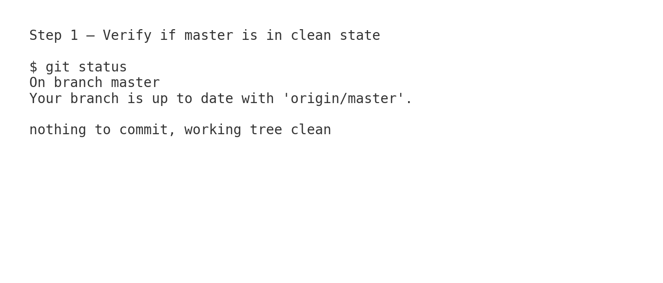

Step 2 – List out all available branches

$ git branch -a  
* master  
 Git-T03-HOL_002  
 remotes/origin/HEAD -> origin/master  
 remotes/origin/Git-T03-HOL_002  
 remotes/origin/master

OUTPUT:

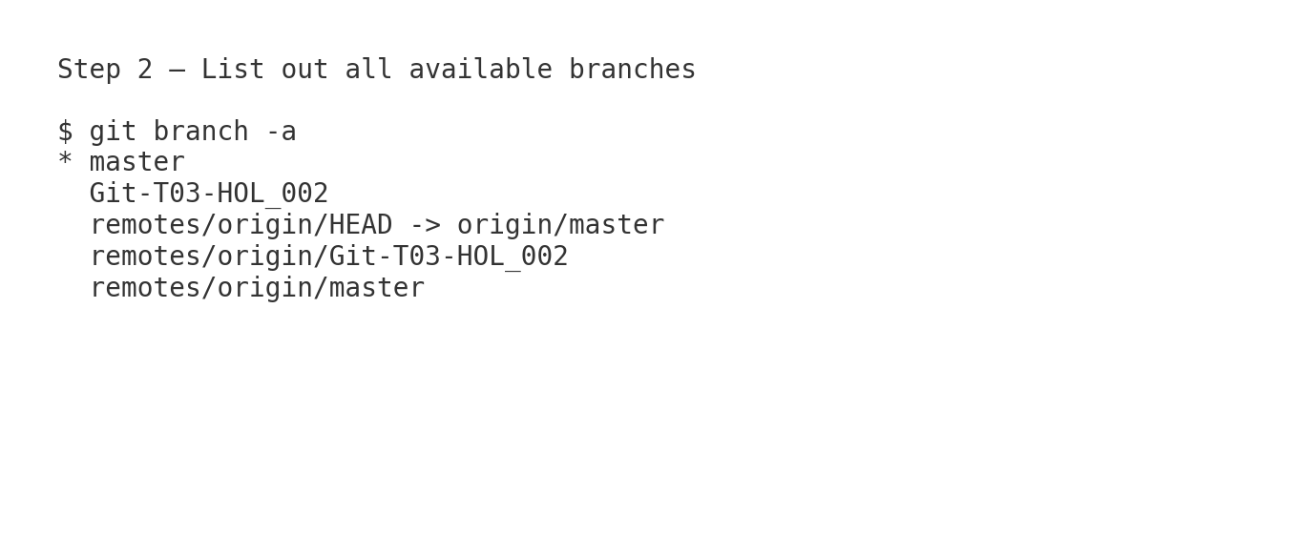

Step 3 – Pull the remote git repository to master

$ git checkout master  
Switched to branch 'master'  
Your branch is up to date with 'origin/master'.  
  
$ git pull origin master  
Already up to date.

OUTPUT:

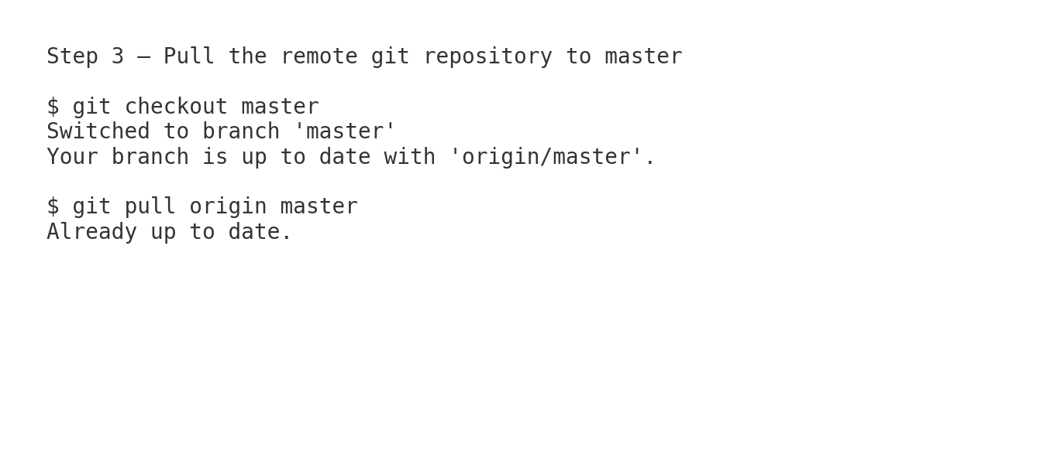

Step 4 – Push the changes from Git-T03-HOL_002 to remote

$ git checkout Git-T03-HOL_002  
Switched to branch 'Git-T03-HOL_002'  
  
$ git add .  
  
$ git commit -m "Completed Git-T03-HOL_002 work"  
[Git-T03-HOL_002 123abc4] Completed Git-T03-HOL_002 work  
 2 files changed, 15 insertions(+), 2 deletions(-)  
  
$ git push origin Git-T03-HOL_002  
Counting objects: 5, done.  
Delta compression using up to 8 threads.  
Compressing objects: 100% (3/3), done.  
Writing objects: 100% (3/3), 456 bytes | 456.00 KiB/s, done.  
To https://github.com/username/repository.git  
 789def0..123abc4 Git-T03-HOL_002 -> Git-T03-HOL_002

OUTPUT:

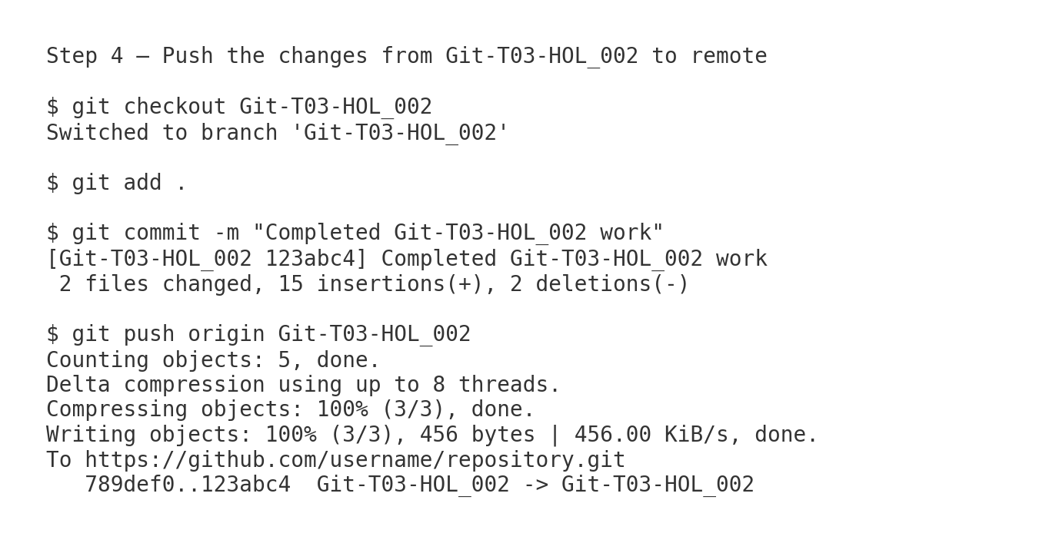

Step 5 – Merge into master and push

$ git checkout master  
Switched to branch 'master'  
  
$ git merge Git-T03-HOL_002  
Updating 789def0..123abc4  
Fast-forward  
 file1.txt | 10 ++++++++--  
 file2.txt | 5 ++++-  
 2 files changed, 12 insertions(+), 3 deletions(-)  
  
$ git push origin master  
To https://github.com/username/repository.git  
 789def0..123abc4 master -> master

OUTPUT:

